
STAT202/3 FORMULA SHEET

  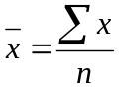
  Q₁ at i = 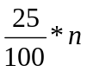
  Q₃ at i = 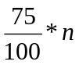
  Q₂ at i = 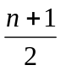
  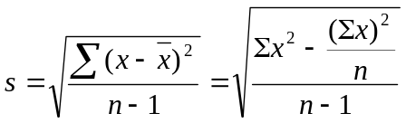
  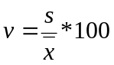%
  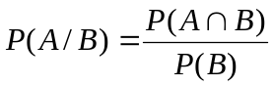
  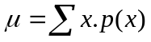
  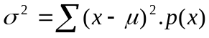
  = Σx²p(x) – [E(x)]²
  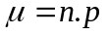
  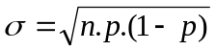
  C.I. = 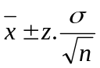
  C.I. = 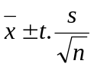
  C.I. = 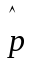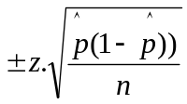
  b = 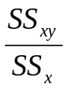
  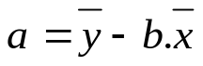
  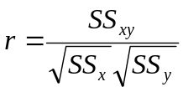
  Simple regression
  Degrees of freedom = n – 2
  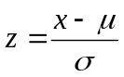
  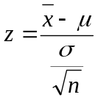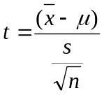
  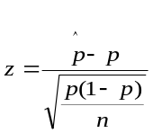
  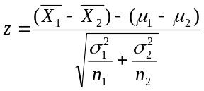
  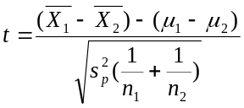
  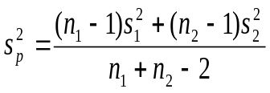
  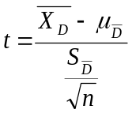
  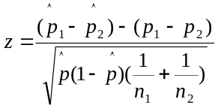
  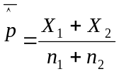
  SSE = SS_{y} - 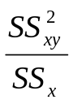
  s_{ε} = 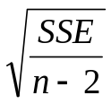
  S_{b} = 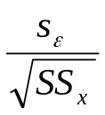
  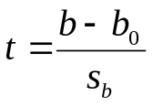

Source of variation | Degrees of Freedom | Sums of Squares | Mean Squares | F-Statistic
Between  Treatments | k – 1 | SST= 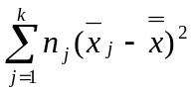 | MST=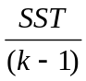 | F = 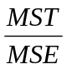
Within Treatments  (Error) | n - k | SSE =  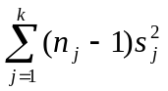 | MSE=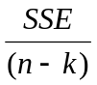
Total | n - 1 | SS (total)

Source of variation | Degrees of Freedom | Sums of Squares | Mean Squares | F-Statistic
Between  Treatments | k – 1 | SST= | MST= | F =
Within Treatments  (Error) | n - k | SSE = | MSE=
Total | n - 1 | SS (total)

Source of variation | Degrees of Freedom | Sums of Squares | Mean Squares | F-Statistic
Between  Treatments | k – 1 | SST= | MST= | F =
Within Treatments  (Error) | n - k | SSE = | MSE=
Total | n - 1 | SS (total)

Source of variation | Degrees of Freedom | Sums of Squares | Mean Squares | F-Statistic
Between  Treatments | k – 1 | SST= | MST= | F =
Within Treatments  (Error) | n - k | SSE = | MSE=
Total | n - 1 | SS (total)

